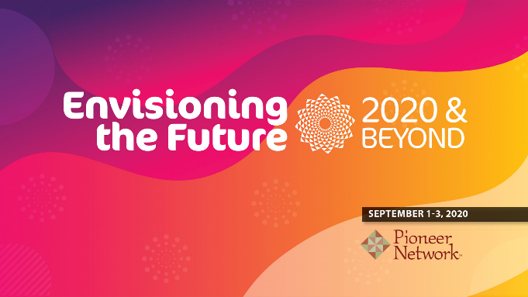
Envisioning the Future:
Through the Eyes of Family Members

ADDITIONAL RESOURCES

- Caregivers for Compromise https://caregivers4compromise.com/

- The Family Experience in Long-Term Care During the Covid-19 visitation restriction http://www.miamioh.edu/cas/academics/centers/scripps/research/publications/2020/07/families-experience-ltc-during-covid-19-visitation-restriction.html

- Meet My Loved One Tool https://www.alliantquality.org/wp-content/uploads/2020/07/AQ_PatientCenteredCareDuringPandemic_MeetMyLovedOne_12SOW-AHSQIN-QIO-TO1CC-20-252_508.pdf

- Meet My Loved One Tips for Implementation https://www.alliantquality.org/wp-content/uploads/2020/07/AQ_TipsForMeetMyLovedOne_12SOW-AHSQIN-QIO-TO1CC-20-256_508-1.pdf

- Ten Ways to Connect and Build Trust with Family Members during COVID-19 https://mailchi.mp/b0d3dd2864de/social-distancing-10-ways-to-still-connect-with-your-new-residents-families

- Deborah Bakti’s podcast http://deborahbakti.com/seniors-care-matters-podcast/

- You are Not Alone Project https://every-day-caregivers.mykajabi.com/you-are-not-alone-project-preview

- The Eden Alternative website www.edenalt.org

- Free virtual learning from The Eden Alternative, including interview with Mary Daniel https://www.edenalt-evolve.org/courses/free-content-eden-alternative-live-emerging-issues-in-the-covid-era

