COMING October 13th 2020 CircleTalk™ Leader Course Leading Virtual Circles
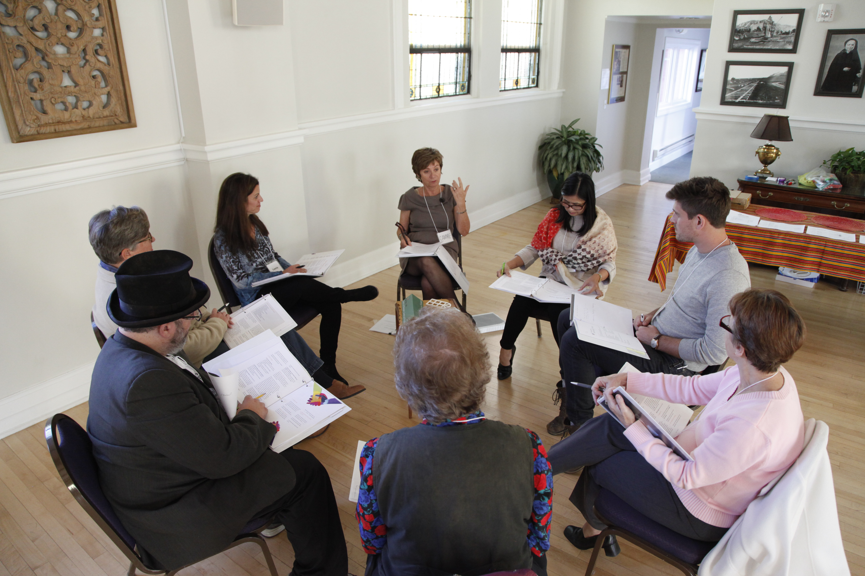 | Facilitating Meaningful Conversations

CircleTalk™ Leader Course-Leading Virtual Circles $495
- In each week of this course, CircleTalk™ faculty teach the lessons critical for learning how to facilitate small groups and implement the CircleTalk™ Curriculum.
- 5 modules: Participants will be guided in an asynchronous and virtual journey through presentations, engaging learning activities and demonstration videos.
- Live coaching calls answer questions and support skill practice through scheduled video calls. Course faculty provide important resources and demonstrations specific to acquiring leader skills.
- Course includes program materials, Instructional Guide and Curriculum Set 1-12.
Go to CircleTalk.org for more information!

